### **Level_Title** : Level container for Title widget

**Description :** Default Level for Game Play. Empty scene overlaid with Title_widget .Requires hold enter to continue.

**Methods :**

1. Constructor :
   1. 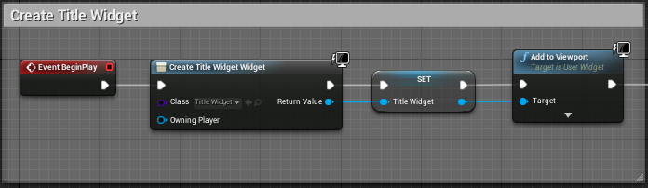
   2. Description : Create Widget, Promote to Variable (TitleWidget), Add to Viewport.
2. Show Mouse
   1. 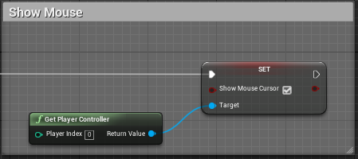
   2. Description : Make mouse cursor visible, clicking not enabled.
3. Destructor :
   1. 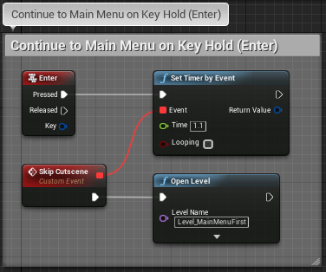
   2. Description : When Enter key is held for 1.1 seconds, Custom Event “Skip Cutscene” is triggered, which opens the level Level_MainMenuFirst

### **Level_MainMenuFirst** : Level container for Main Menu scene

**Description :**  Main Menu scene, has fixed camera view, and overlaid with MainMenu_widget.

**Methods :**

1. Constructor :
   1. 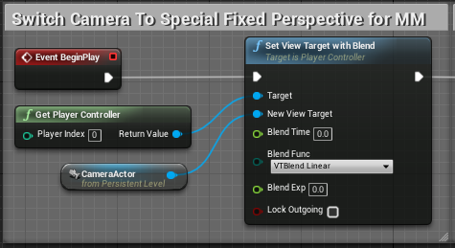
   2. 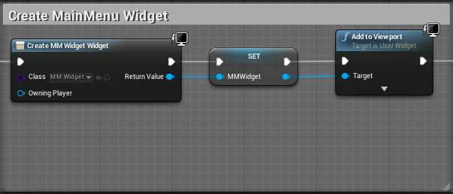
   3. Description : Set camera to custom Camera Actor, Create Widget, Promote to Variable (MMWidget), Add to Viewport.
2. Release Mouse
   1. 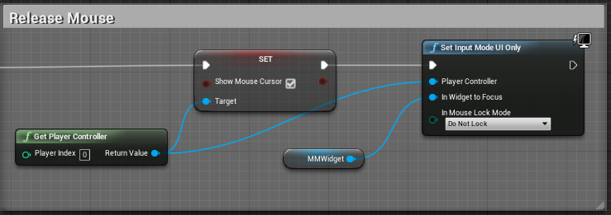
   2. Description : Releases Mouse, Sets Input Mode to UI Only

### 

### **Level_Credits** : Level container for Credits widget

**Description :**  Only accessible from Main Menu and Game Over State. Empty scene overlaid with Credits_widget.

**Methods :**

1. Constructor :
   1. 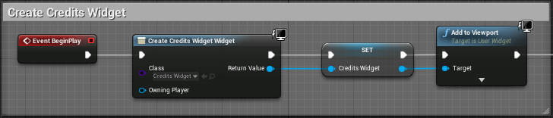
   2. Description : Create Widget, Promote to Variable (CreditsWidget), Add to Viewport
2. Release Mouse
   1. 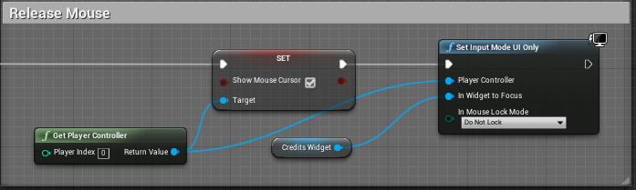
   2. Description : Releases Mouse, Sets Input Mode to UI Only

### 

### **Level_CutScenesFirst** : Level container for CutScene_Player_widget

**Description :**  Empty scene overlaid with CutScene_Player_widget.

**Methods :**

1. Add Sound
   1. 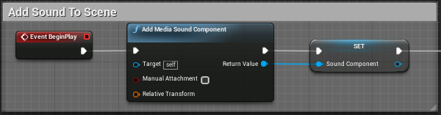
   2. Add Media Sound Component for cutscene, Promote to Variable
2. Constructor :
   1. 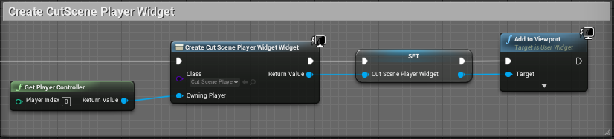
   2. Description : Create Widget, Promote to Variable CutScene_Player_Widget), Add to Viewport
3. Skip CutScene
   1. 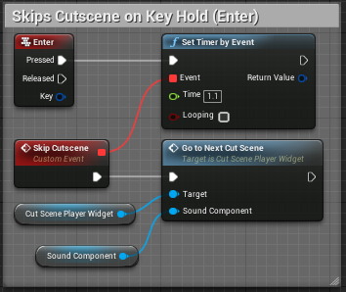
   2. Description : When Enter key is held for 1.1 seconds, Custom Event “Skip Cutscene” is triggered, which calls “Go to Next Cut Scene” function

### 

### **Level_MapRoom** : Level for Map Image, At start of each tier of the temple

**Description :** Simple level design, front camera view only, movement from left to right. Door on right exits and triggers loading of next level

**Methods :**

1. Constructor
   1. 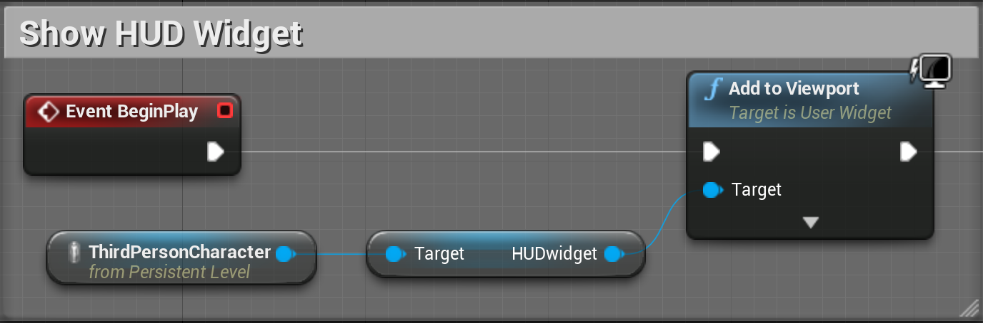
   2. Description : Show HUD Widget
2. Set Camera Perspective
   1. 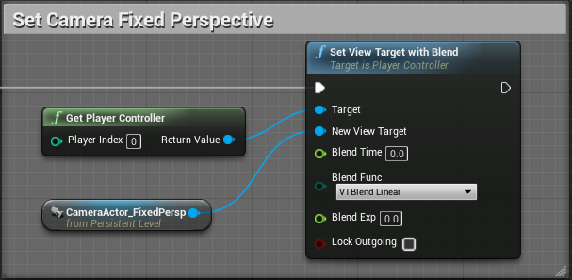
   2. Set camera to custom Camera Actor (Fixed Perspective)
3. Exit Level on Trigger Box Overlap
   1. 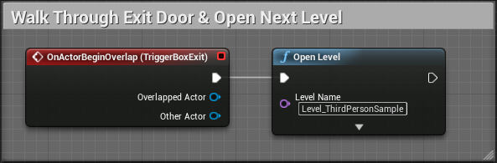
   2. Description : When Player Character overlaps Trigger Box at exit door, open Level_ThirdPersonSample
4. “Inverted” Movement Input
   1. 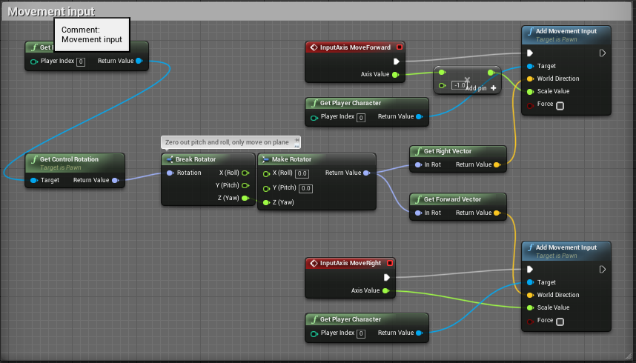
   2. Description : Inverts default Player Controller movement to allow properly oriented left-to-right movement in Level_MapRoom

### 

### **Level_ThirdPersonSample** : Sample Level for Showcasing Mechanics

**Description :** Demonstrates functionality of gameplay mechanics for Prototype Demo

**Methods :**

1. Constructor
   1. 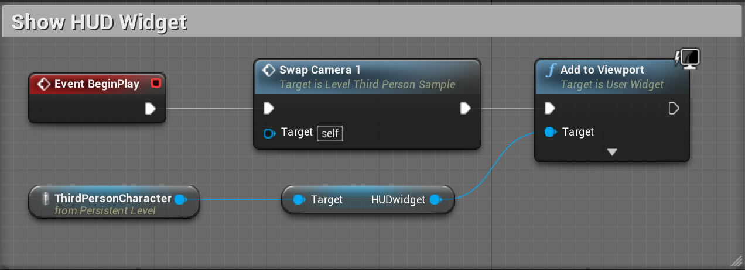
   2. Description : Shows HUD_Widget
2. Execute Mechanics on Mouse Click
   1. 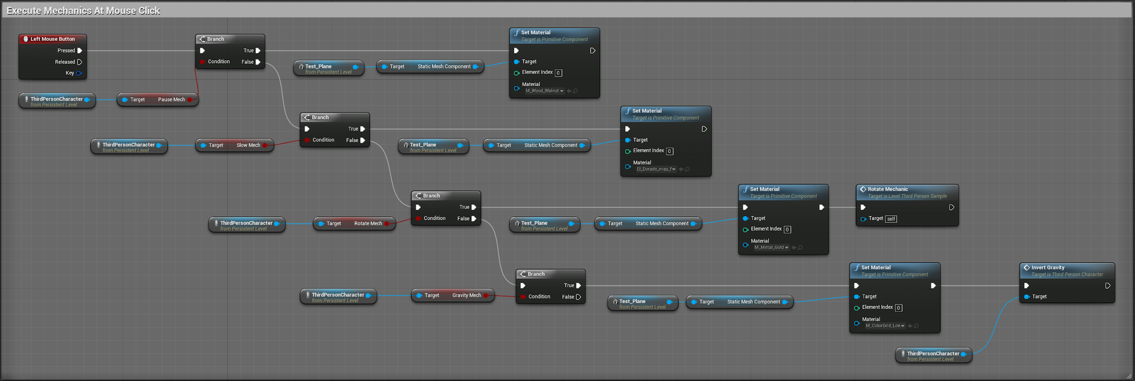
   2. 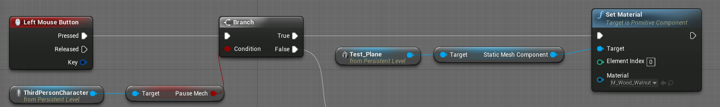
   3. 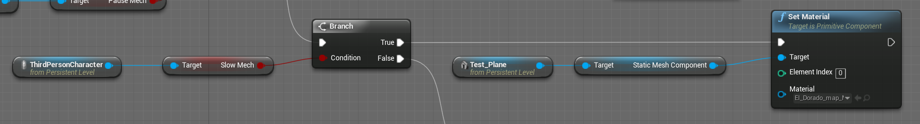
   4. 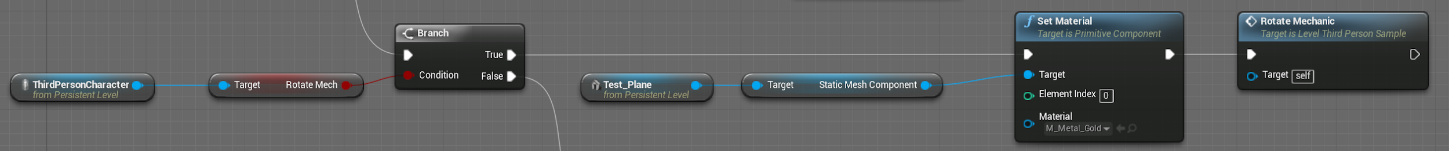
   5. 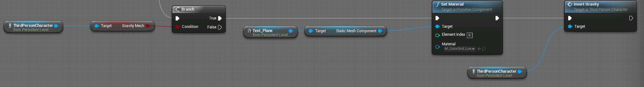
3. *Function* : Rotate Mechanic
   1. 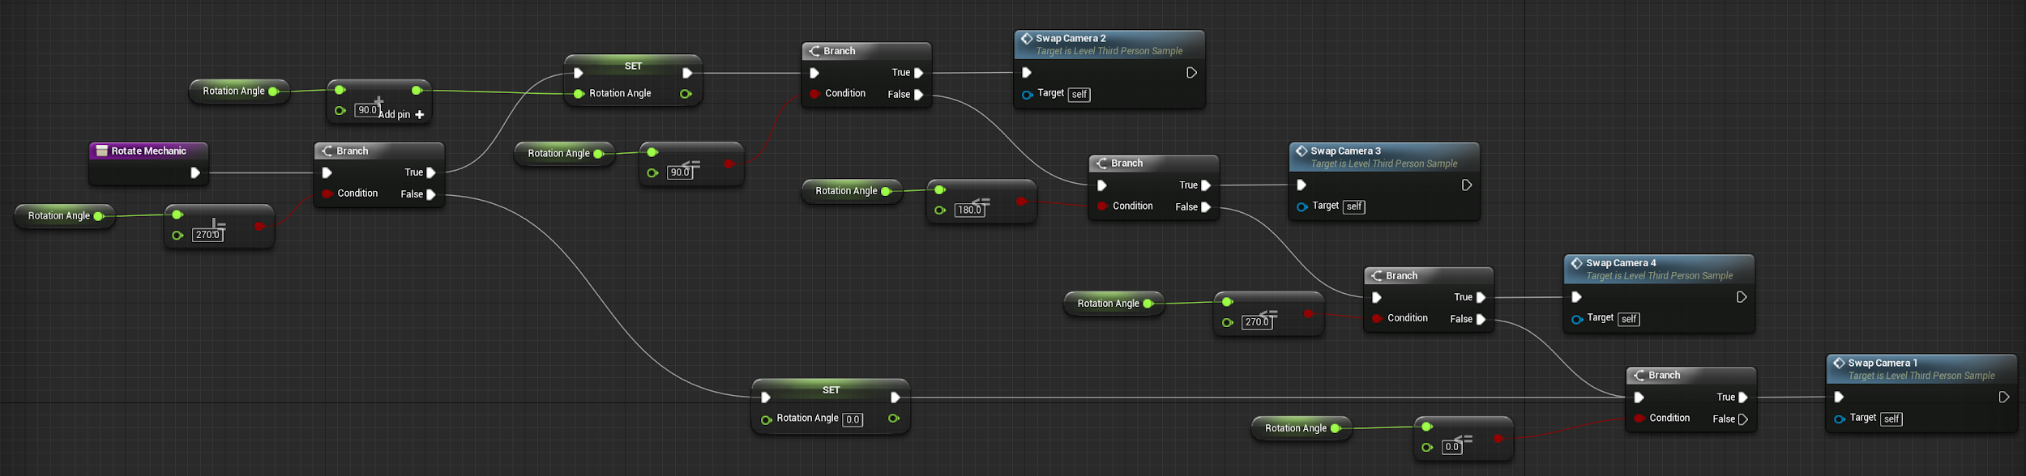
   2. Description : Sequentially rotates between four cameras by calling SwapCamera function when Rotation Mechanic is selected (Keypress 3) and Left Mouse is clicked
4. *Functions :* Swap Camera 1 - 4
   1. 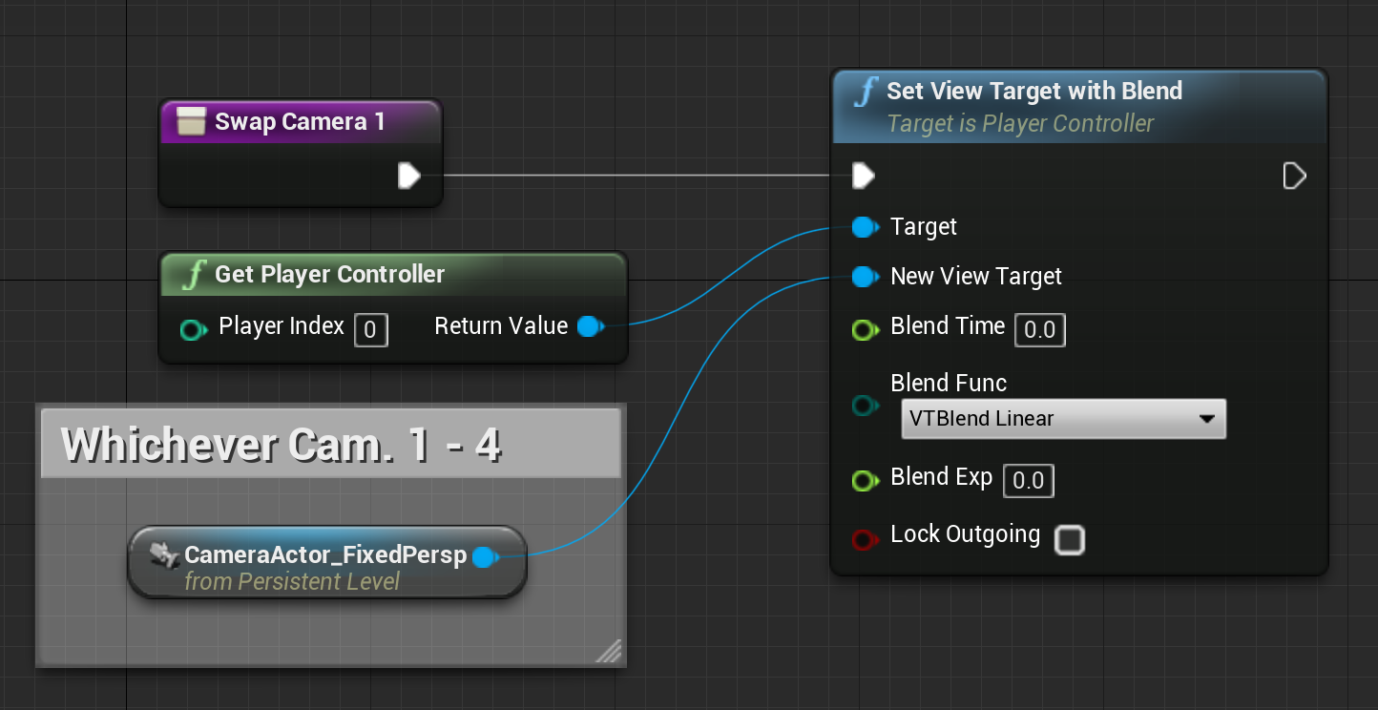
   2. Description : Swap view to Specific Camera (CameraActor)

### **ThirdPersonCharacter** :

**Description :** Demonstrates functionality of gameplay mechanics for Prototype Demo

**Methods :**

1. Open Journal on Keypress
   1. CallJ for Journal function
      1. 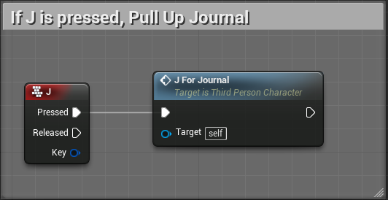
   2. *Function* : J for Journal
      1. 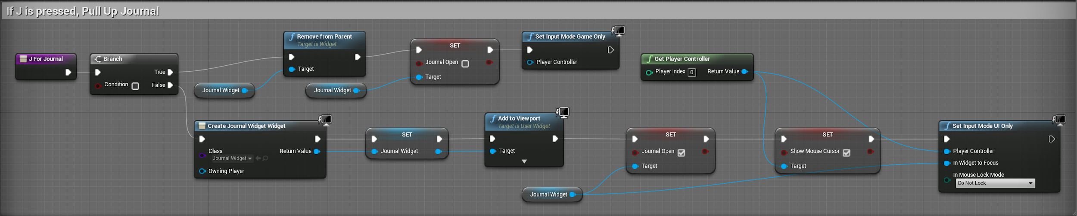
   3. Description : When the J key is pressed, check if game is paused.
      1. if condition true, remove widget from viewport and Set Input Mode Game Only **\*\*Currently broken, use “resume” button in Journal\*\***
      2. If condition false, create Journal_Widget, Promote to Variable, Add to Viewport, **\*\*Broken/Useless bool\*\***, Show Mouse Cursor, Set Input mode UI Only
2. Pause Game on Keypress
   1. Call P for Pause function
      1. 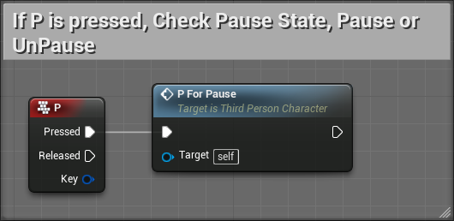
   2. *Function* : P for Pause
      1. 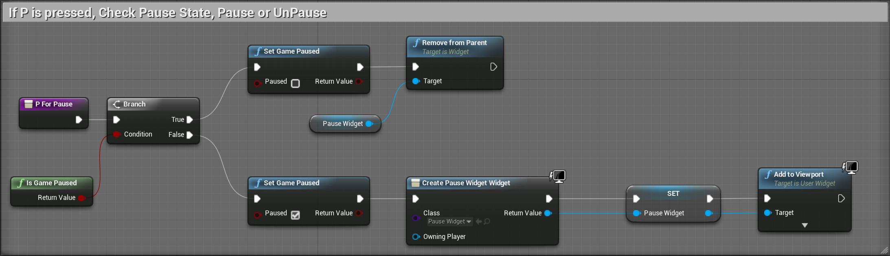
   3. Description : When the P key is pressed, check if game is paused.
      1. If game is paused, set game Not Paused, remove Pause widget from viewport
      2. If game is not paused, set game Paused, create Pause_Widget, Promote to Variable, Add to Viewport
3. Inner Dial Rotation

   2. 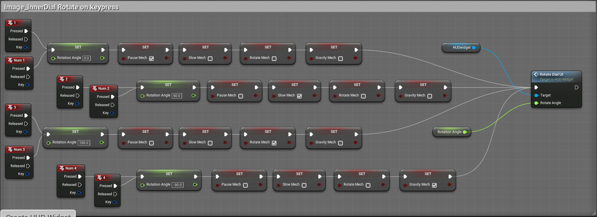
   3. Description : Passes angle variable to Rotate SubRoutine of HUD_widget, angles correspond to 1-4 Keyboard Input representing the 4 game mechanics on the outer dial. Sets appropriate mechanic to “active” and all other mechanics to “inactive”
4. Create HUD Widget
   1. 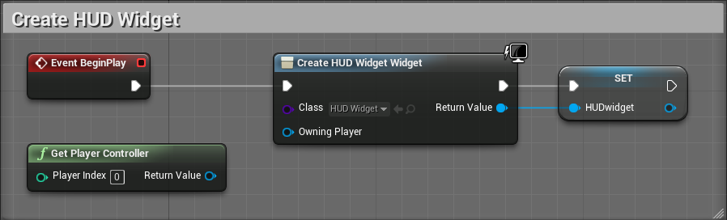
   2. Creates HUD_Widget on BeginPlay and promotes to variable
5. *Function* :
   1. 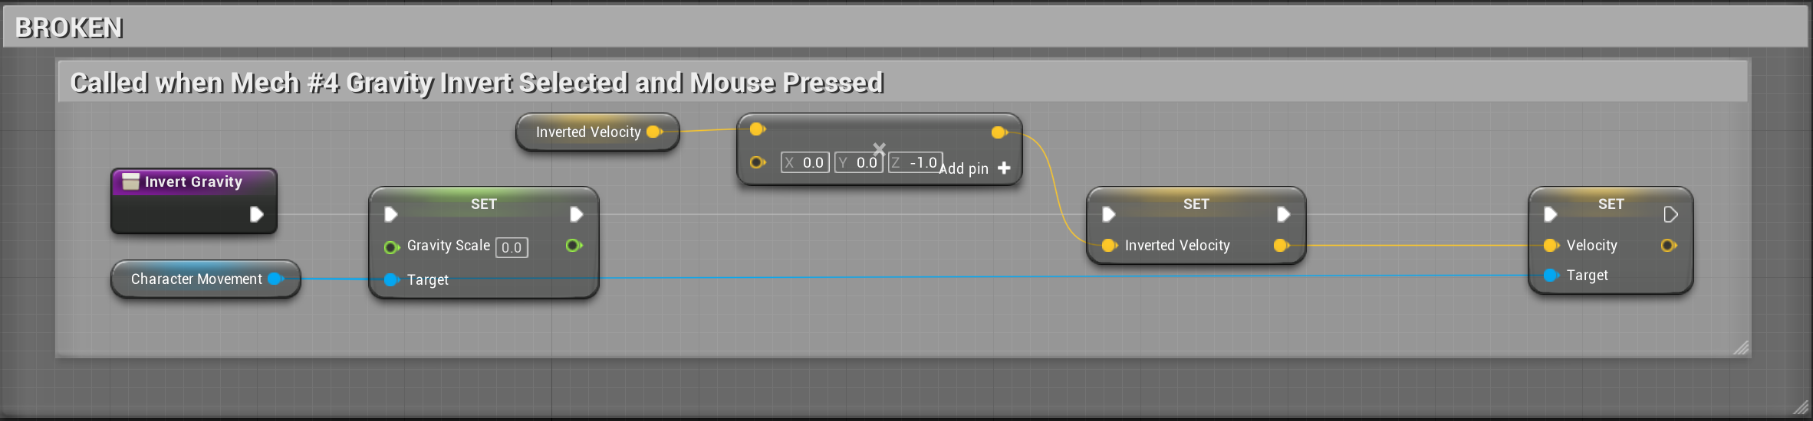

### **Cutscene_Player_Widget :** Controls Cutscenes to Viewport

**Description :** Maintains and plays videos for cutscenes

**Methods :**

1. Open Playlist on Construct
   1. 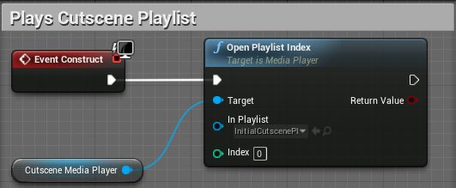
   2. Description : Opens playlist at given index on Event Construct using target Media Player
2. *Function* : GoToNextCutScene
   1. 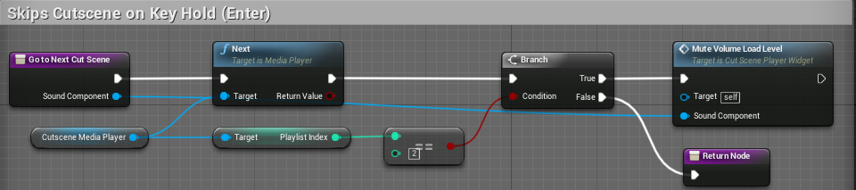
   2. Description : When the function is called, skip to next video in the playlist of the target Media Player, then return the index of the video. If the playlist index is equal to the given number (2), call function MuteVolumeLoadLevel
3. *Function* : MuteVolumeLoadLevel
   1. 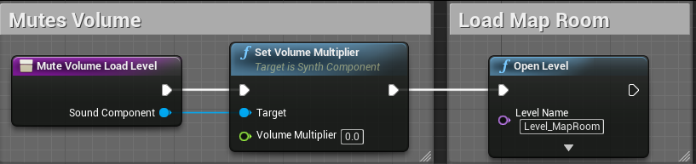
   2. Description : When the function is called, set volume multiplier to zero (muting the media), then open Level_MapRoom

### 

### **Journal_Widget :** Contains Journal Functionality & Images

**Description :** Contains options for resume, exit to desktop, exit to main menu, and save.

**Methods :**

1. Resume Game
   1. 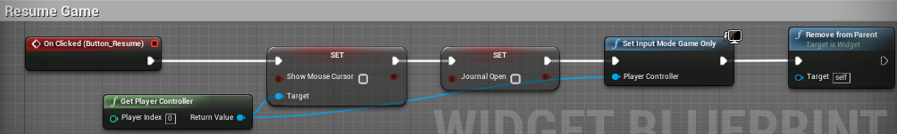
   2. Description : When Button_Resume is clicked, set Show Mouse Cursor to false, set Journal Open to false, Set Input Mode Game Only, then remove widget from viewport
2. Exit to Desktop
   1. 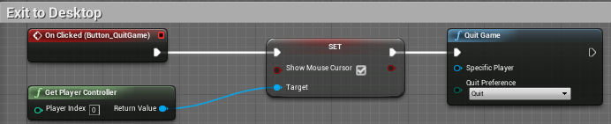
   2. Description : When Button_QuitGame is clicked, set Show Mouse Cursor to true, then quit game.
3. Exit to Main Menu
   1. 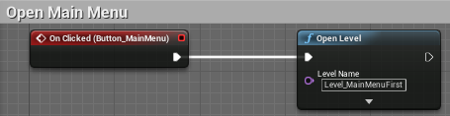
   2. Description : When Button_MainMenu is clicked, open Level_MainMenuFirst
4. Save Game
   1. 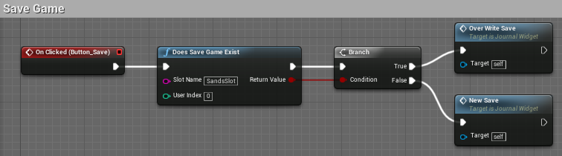
   2. Description : When Button_Save is clicked, check if Save Game exists in SandsSlot
      1. If save exists: Call function OverWrite_Save
      2. If save does not exist: Call function New_Save
5. *Function* : OverWrite_Save
   1. 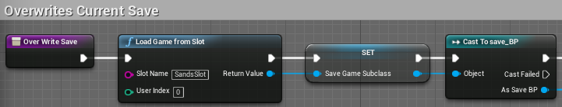
   2. 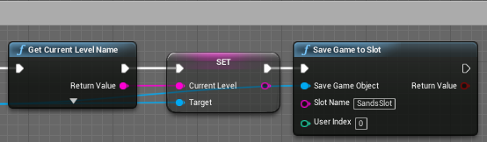
   3. Description : When OverWrite_Save is called, load Save Game from slot, set information to Save Game subclass, Cast to save_BP, get current level name, set current level in Save Game information, save game to SandsSlot
6. *Function* : New_Save
   1. 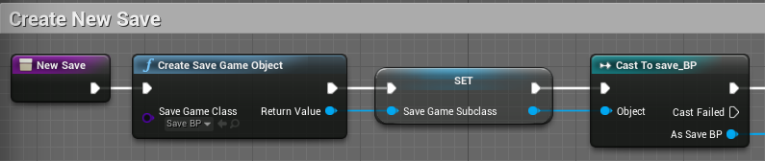
   2. 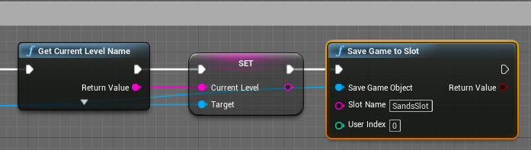
   3. Description : When New_Save is called, create new Save Game Object, set information to Save Game subclass, cast to save_BP, get current level name, set current level in Save Game information, save game to SandsSlot

### 

### **HUD_Widget :** Contains HUD Images

**Description :** Contains imagery for HUD and controls Inner Dial Rotation

**Methods :**

1. *Function* : Rotate Dial UI
   1. 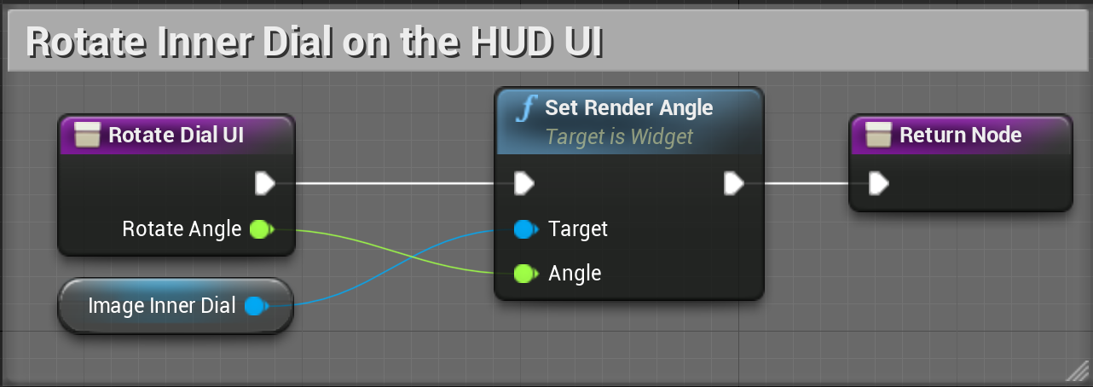
   2. Description : Rotates Image_InnerDial from center pivot-point along vertical axis by an angle

### **Pause_Widget :** Display Pause Screen

**Description :** When game is paused, displays Pause Widget screen

**Methods :** None (*Activated by Keypress called in ThirdPersonCharacter*)

### **Title_Widget :** Display Title Screen

**Description :** Contains imagery for Title Screen

**Methods :** None

### **Credits_Widget :** Display Credits Screen

**Description :** Contains imagery for Credits Screen

**Methods :**

1. Go Back to Main Menu
   1. 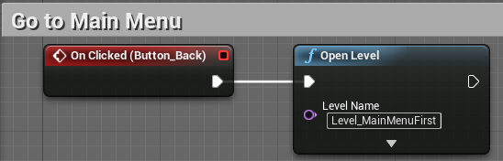
   2. Description : When Button_Back is clicked, open Level_MainMenuFirst

### 

### **MM_Widget :** Display Main Menu & Contains Button Functionality

**Description :** Presents player with buttons for Main Menu functionality

**Methods :**

1. Constructor
   1. 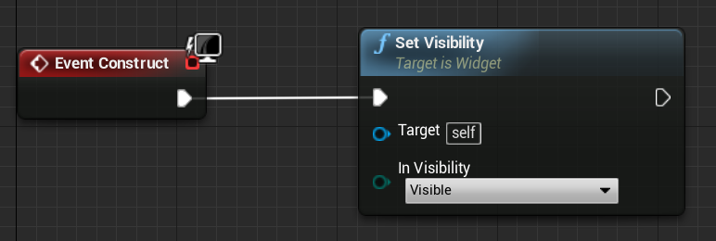
   2. Description : Sets visibility of MM_Widget
2. New Game
   1. 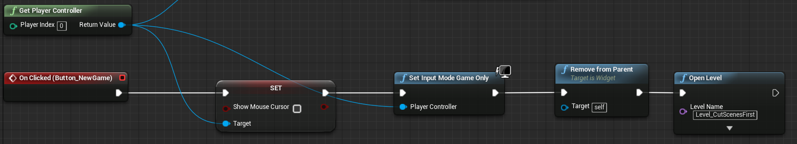
   2. Description : On clicked Button_NewGame, sets mouse cursor to Not Visible, sets Input Mode Game Only, removes MM_Widget from screen and opens Level_CutScenesFirst
3. Continue
   1. 
   2. Description : On clicked Button_Continue, continues from Save Game in SandsSlot by opening Current Level saved to variable in save_BP
4. Options
   1. 
   2. Description : On clicked Button_Options, set Main Menu buttons to Not Visible and set Options button to Visible
   3. Back Button Show Main Menu instead of Options
      1. 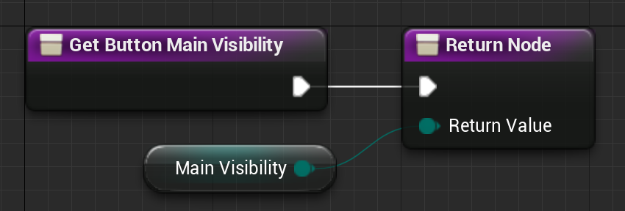
   4. Show Options Instead of Main Menu
      1. 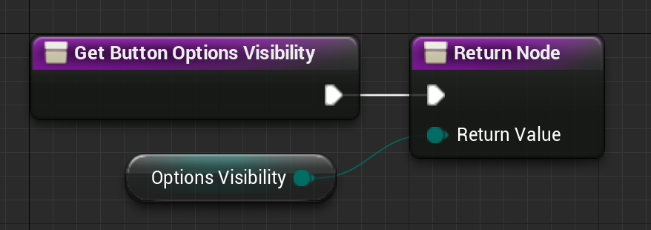
   5. Set Resolution
      1. 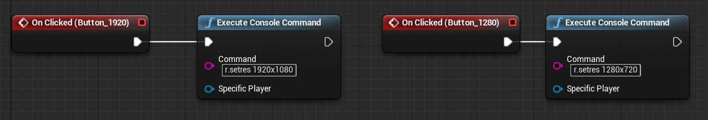
      2. Description : On clicked Button_1920 or Button_1280, sets window resolution accordingly
5. Credits
   1. 
   2. Description : On clicked Button_Credits, open Level_Credits
6. Quit
   1. 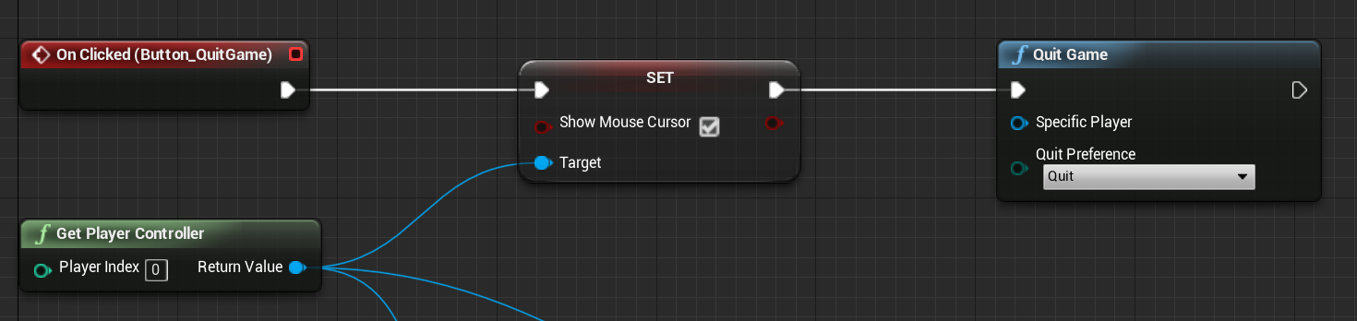
   2. Description : On clicked Button_QuitGame, set mouse cursor to Visible and exit game